DIVISIONAL STARTING ORDER FOR DAY 1 (MONDAY)

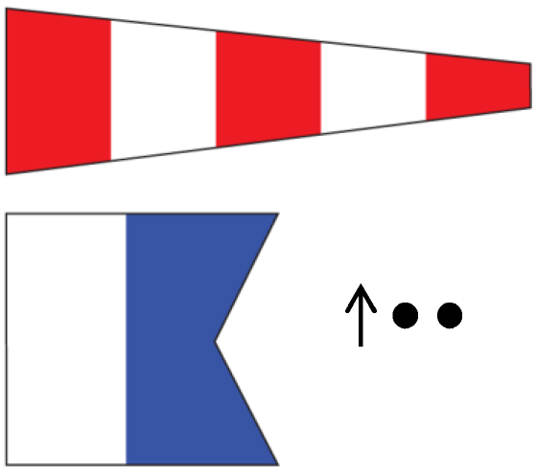

AP over A Races not started are postponed. No more racing today.

Due to the Gale warning issued by the Bureau of Meteorology for the racing area there will be no racing today.

